Team Firetruck

**Architecture Design:**

VibeCheque is a Discord bot written in the Discord.JS framework.

Discord provides APIs to interact with the client in many ways. Discord.JS is a NodeJS module that allows developers to write object oriented code that easily interacts with Discord’s API. We chose this framework for its ease of use in creating Discord bots.

**Architecture Design Diagram**:  
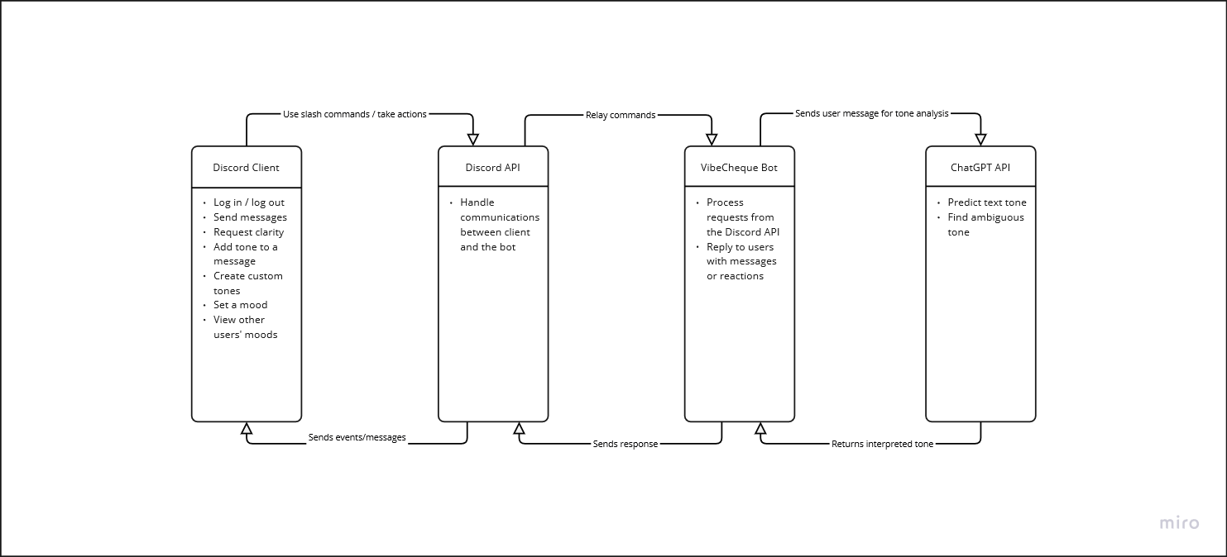

**Design Description:**

The architectural pattern consists of four components: the client (Discord), the Discord API, our bot VibeCheque, and ChatGPT API.

Discord client handles all the essential functionalities of our application. Users can send messages to other users and interact with the bot using slash commands. They can also view reactions made to the messages. The user sets a bot up by adding it to a server or a private conversation, and then they will be able to use the full capabilities of the bot.

Discord API allows external code to interact with the client. Through the API, we can send/edit/delete messages, react to messages and read the incoming texts from the users.

Our bot uses event callbacks to interact with the API. When certain actions happen (such as tagging the bot in the text or using slash commands), Discord.JS makes a callback to handle the event by the appropriate action. The bot can make a request to ChatGPT API to analyze the user texts

ChatGPT API enables us to send requests to ChatGPT and get a response from it as a JSON object. The generated responses are passed on to our bot, which sends it back to the client through the Discord API.